Case Study:

You work as a Devops Engineer in a leading Software Company. You have been asked to Dockerize the applications on the production server. The company uses custom software, therefore there is no pre-built container which can be used.

Assume the following things:

1. Assume the software to be installed is apache

2. Use an Ubuntu container

The company wants the following things:

1. Push a container to DockerHub with the above config

2. The Developers will not be working with Docker, hence from their side you will just get the code. Write a Dockerfile which could put the code in the custom image that you have built

Process:

1. Creating Dockerfile

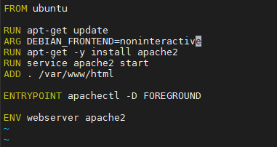

1. Creating sample html file which will run on apache2 webserver

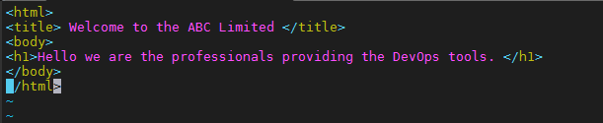

1. Run this “docker build . -t <name the image: ubuntu_apache2 >” to build the image.4
2. 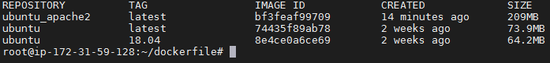Verify by “docker image ls”
3. Run the command “docker container run -d -p 32000:80 –name webserver ubuntu_apache2” to build the container.
4. The same can be verified by “docker container ls”
5. Now as container is running and it has sample html code. The same can be verified by the url with port number.
6. 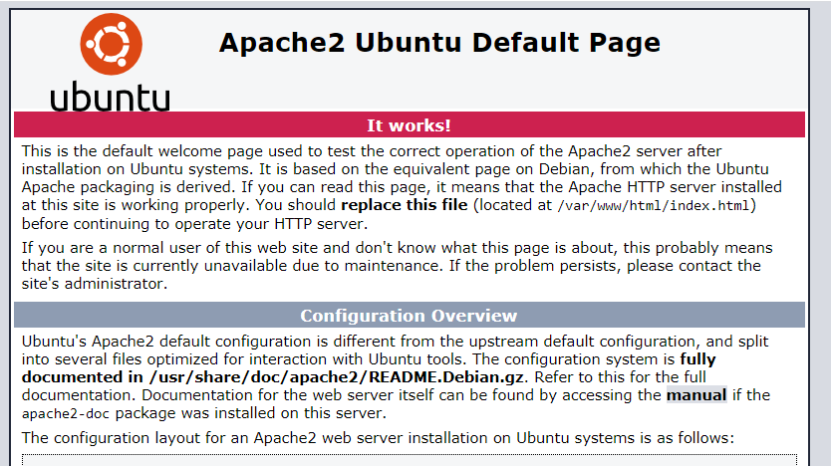And the html page:
7. 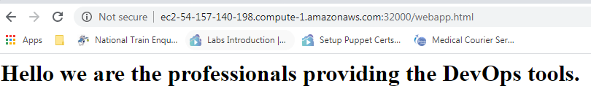Push the image to Docker Hub with the command ‘sudo docker push tusharpatil985/ubuntu_apache2”